Dear High School Class of 2024,
Congratulations! You have made it to your senior year! We know this is a very busy and exciting year for you. We reach out today to highlight a new statewide initiative that you will experience in its first year.
Initiated by Governor Brian Kemp, GEORGIA MATCH will show you all of the public colleges and universities in Georgia for which you have met the initial academic requirements for admission.
The GEORGIA MATCH program and the financial aid resources available at www.GAfutures.org will help you identify the best college or university in Georgia to achieve your higher education and career goals.

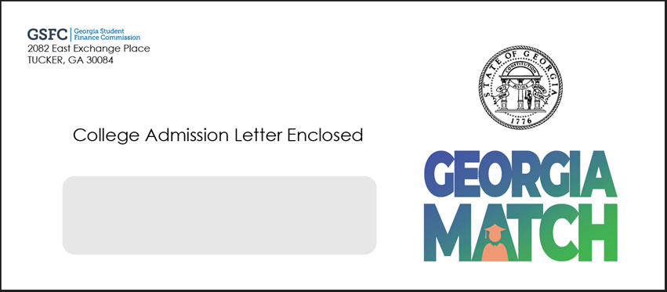

GEORGIA MATCH letters will be placed in the mail on October 10th – look for the envelope shown here!!

The GEORGIA MATCH initiative is a collaboration between the Georgia Student Finance Commission (GSFC), the University System of Georgia (USG), the Technical College System of Georgia (TCSG), the Georgia Department of Education (GaDOE), and the Governor’s Office of Student Achievement (GOSA).

